11.2 Hybrid Data & Semi-Structured Intelligence Lab Report

Thomas Adkins
BAT Program, Lone Star College
ITCS-3330 W005 1 Applied Database Management
Dr. Watson
April 12, 2026

Hybrid Data & Semi-Structured Intelligence Lab
Part 1: The XML Sensor Integration
- Access MySQL Within the Node: Once a terminal session has been initiated, use the incus shell command to access the gsoc-node then log into MySQL. (see figure 1)
Figure 1:
Entering MySQL within the gsoc-node
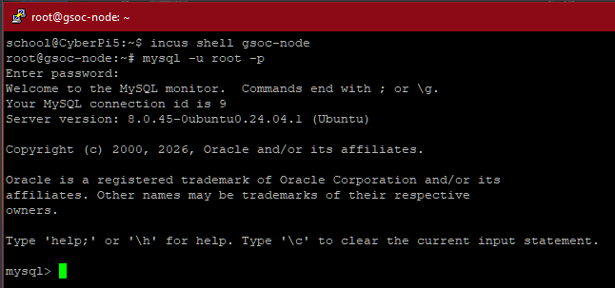
- Preparation: Execute SHOW databases; to view all of the databases located within the node and to confirm that the GSOC_Security database is present. Then execute USE GSOC_Security; to ensure that you are working in the correct database. (see figures 2-3)
Figure 2:
Viewing gsoc-node databases and using the GSOC_Security database
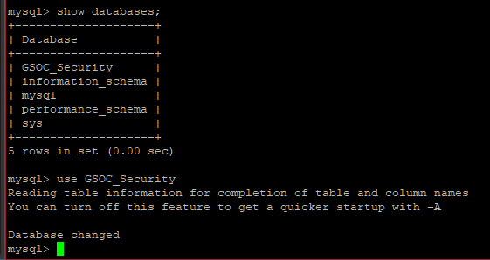
Figure 3:
Viewing all tables within the database
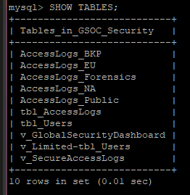
- Schema Evolution: Use an ALTER TABLE statement to add a column to the tbl_AccessLogs table that will be used to store a raw XML string.
Figure 4:
Adding a column to store XML strings
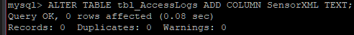
- Creating a Test User: Use an INSERT statement to create a new user that will be needed for the next step when we simulate a biometric sensor log (see figure 5).
Figure 5:
Creating a user with an ID of 888
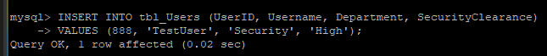
- Log Simulation and Extraction: To simulate a biometric sensor, execute the INSERT INTO statement seen in figure 6, then run a select statement that extracts the firmware version from the XML for user 888 that was created in step 4. (see figure 6)
Figure 6:
Commands to simulate a biometric sensor log and to extract data
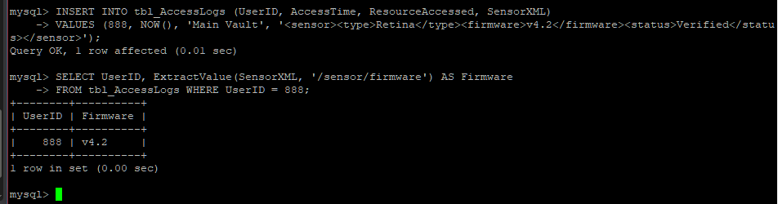
Part 2: The JSON Threat Intelligence (Object Logic)
- Add the JSON Column: Execute an ALTER TABLE statement to add the JSON column to the tbl_AccessLogs table. (see figure 7)
Figure 7:
Command to add a JSON column
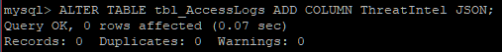
- The Guided Update: Execute an UPDATE statement to add a high-risk JSON object to User 888’s log. (See figure 8)
Figure 8:
Statement to add a high-risk JSON object to user 888
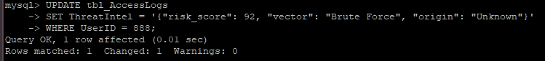
- The JSON Path Query: Use the -> operator to find high-risk events where the score is greater than 90. User 888 should appear with a risk score of 92. Run exit; when finished. (see figure 9)
Figure 9:
Statement to find high-risk events with a score above 90
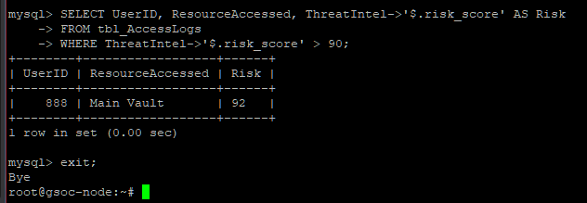
Part 3: Linux CLI Pattern Matching
- Search the Data: Use the Linux grep command to search for the XML metadata inside of the dump file. (See figures 10-11)
Figure 10:
Grep statement output
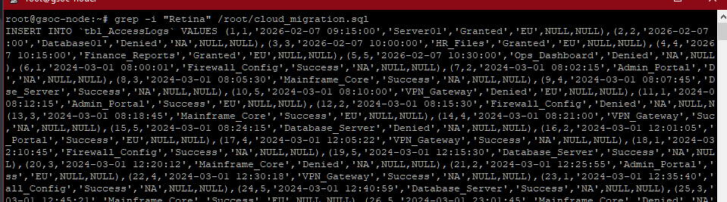
Figure 11:
Retina is found within the grep command and colored red
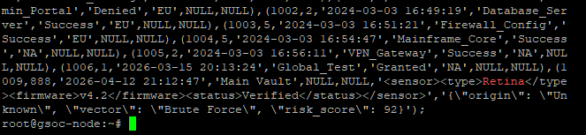
Personal Reflection
Architectural Flexibility: Based on my results from Part 1, it is more efficient to add a single SensorXMLcolumn rather than adding three separate columns for SensorType, SensorFirmware, and SensorStatus because it helps to preserve schema flexibility as the data changes over time. In realistic environments, data is not always “clean” and different hardware and programs could include different metadata. If the schema relied on individual columns per attribute, every new sensor type that appears over time would require an ALTER TABLE statement, which could be disruptive to normal operations and open the doors for potential errors to be made. By storing this information as a single TEXT value combined with MySQL’s ExtractValue function, specific fields can be queried on demand without locking the schema to a fixed structure.
Object-Oriented Extensions: During Parts 1 and 2, I used ExtractValue and the -> operator to query semi-structured data stored inside standard table columns, which is what allows MySQL to behave like an object-oriented system without fully abandoning the relational model. In object-oriented programming, data is stored as objects with individually accessible properties, and these functions replicate that behavior directly inside SQL. When I ran ExtractValue(SensorXML, '/sensor/firmware'), MySQL treated the XML string as a structured object and navigated to the firmware property using an XPath expression, returning v4.2 without needing a dedicated column for it. The -> operator works the same way for JSON — ThreatIntel->'$.risk_score' parsed the stored object and pulled just that one field, allowing me to filter by risk score the same way I would any standard relational column.
GSOC Use Case: A security firm would generally prefer to store raw JSON from a third-party firewall API rather than trying to force the data into a normalized table as third-party API’s are generally out of the control of the consumers that use them. Vendors can update their API at any time to add new updates and features that could cause a normalized schema to break. By storing the raw JSON directly in a dedicated column, the data is preserved exactly as it originally arrived, resulting in an accurate and reliable solution.

